Integrating Whisper AI with FARGO to Enable Multilingual Voice Interaction  
  
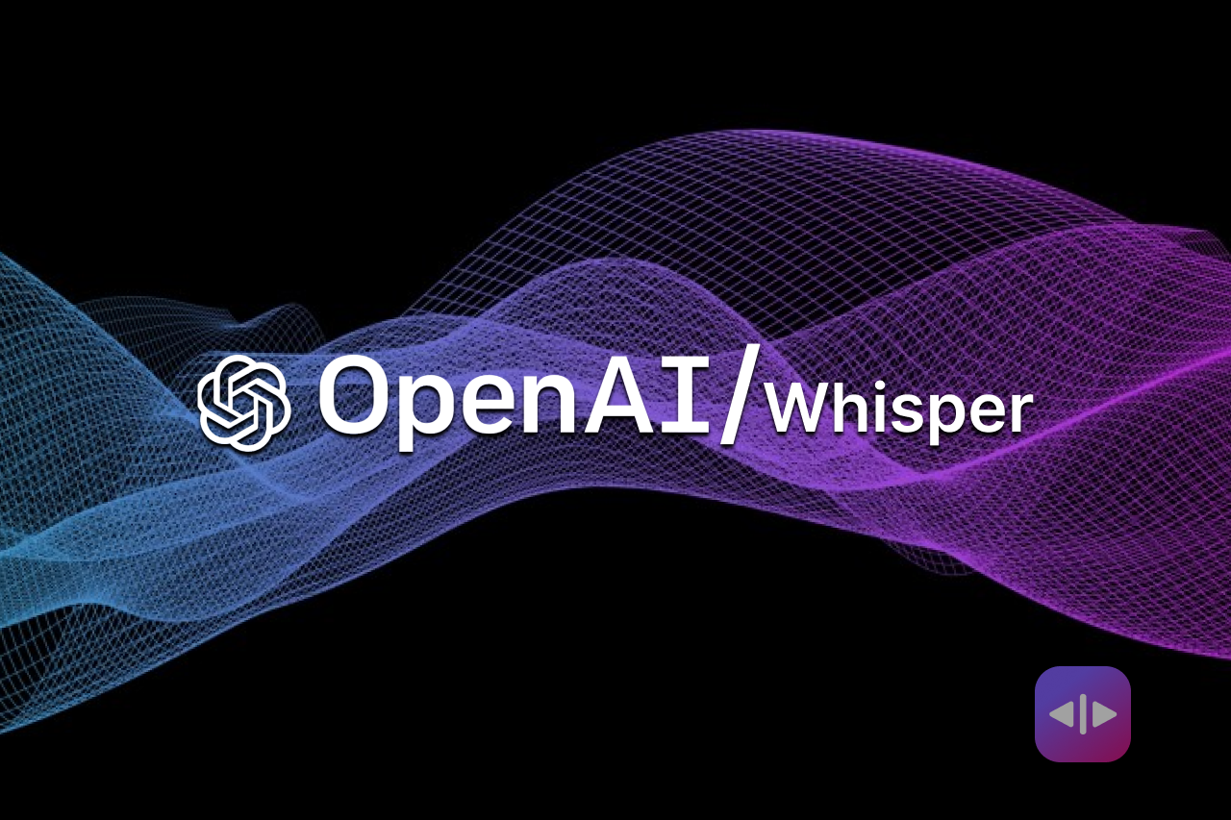





Abstract:

In an increasingly interconnected world, the ability to seamlessly communicate across languages presents a significant challenge. While Wells Fargo's FARGO chatbot currently supports English and Spanish, there is a growing need to expand accessibility for customers who speak diverse languages. Whisper AI offers a solution by integrating its advanced automatic speech recognition (ASR) capabilities, trained on a vast multilingual dataset, to enable real-time transcription and translation. This integration aims to enhance customer interaction by allowing users to communicate in their native languages, with translations provided in English.

Problem Statement:

Wells Fargo's FARGO chatbot is currently limited to supporting English and Spanish, posing barriers for customers who prefer to interact in other languages. Traditional methods of text-based communication may not always meet the needs of users, especially in scenarios requiring quick and accurate information exchange.

Proposal:

Integrate Whisper AI's ASR system with FARGO to facilitate seamless multilingual communication. Whisper AI's technology, trained on extensive multilingual data, enables accurate transcription and translation of spoken languages into English, thereby enhancing user experience and accessibility.

Approach:

Utilize Whisper AI's end-to-end encoder-decoder Transformer architecture, capable of processing audio inputs in multiple languages. Input audio is segmented and processed into log-Mel spectrograms, which are then transcribed or translated using a trained decoder. This approach ensures robustness to accents, background noise, and technical language variations.

Solution:

By integrating Whisper AI into FARGO, Wells Fargo can offer a sophisticated multilingual interface that supports real-time speech-to-text and translation functionalities. This empowers users to interact in their preferred language, enhancing accessibility and user satisfaction.

Advantage:

* **Enhanced Accessibility:** Facilitates communication in over 99 languages, accommodating diverse customer needs.
* **Improved User Experience**: Provides a natural and intuitive interface for users to interact via speech, reducing reliance on text-based inputs.
* **Confidentiality:** Leveraging Whisper AI's open-source model ensures data privacy and security, crucial for banking applications.

Name: Ayan Jain

KID: K097130

Team: FARGO Accounts, DTI